**Housing Section**

A screenshot of a social media post

Description generated with very high confidence

**Housing Home Page:**

* By clicking ‘Manage Housing Type’ admin will be redirected to manage housing type page.
* By clicking ‘Manage Housing’ admin will be redirected to manage housing page.
* By clicking ‘Search Housing User’ user will be able to search user.

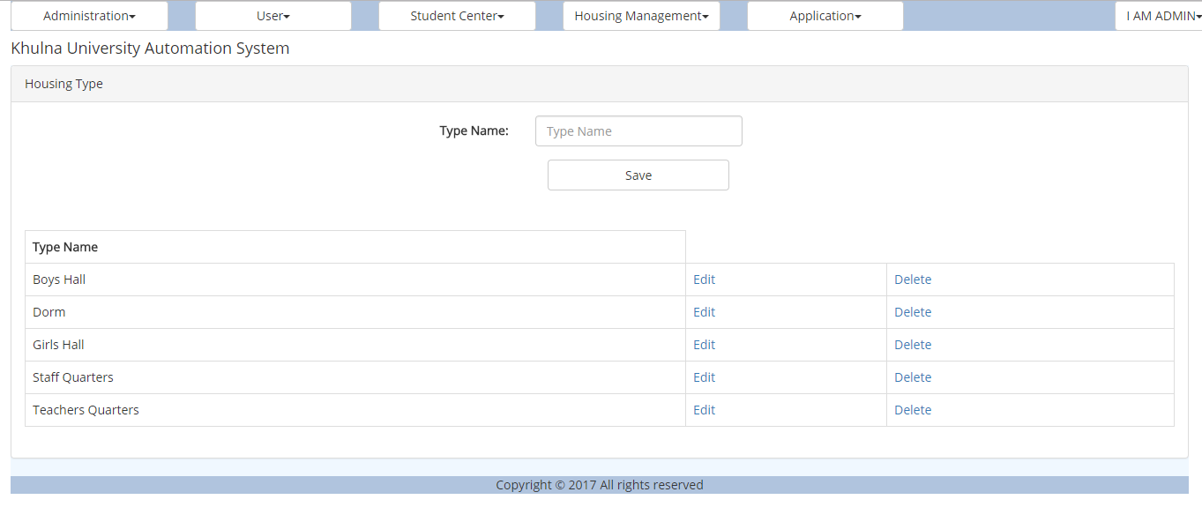

**Housing Type Page:**

* In this page a new type of housing can be created.
* Admin can edit and delete housing type.

A screenshot of a social media post

Description generated with very high confidence

**Manage Housing:**

* In this page admin will be able to create a new page entering the name, type, floors and no. of rooms.
* Clicking the housing name user will be redirected to detais page.
* Admin can add details of the housing clicking ‘Details Add’.
* Admin can edit and delete housing.

A screenshot of a social media post

Description generated with very high confidence

**Housing Room:**

* Admin can and delete room from here.
* By clicking room no will be able to see details of the room.

A screenshot of a social media post

Description generated with very high confidence

**Housing Room Assign:**

* User can be assigned and remove in a specific room.

A screenshot of a social media post

Description generated with very high confidence

**Add Housing Details:**

* Admin can add details and manage the details here.

A screenshot of a social media post

Description generated with very high confidence

**User Search:**

* User can be searched filling the criteria.

**Hall Permission Section**

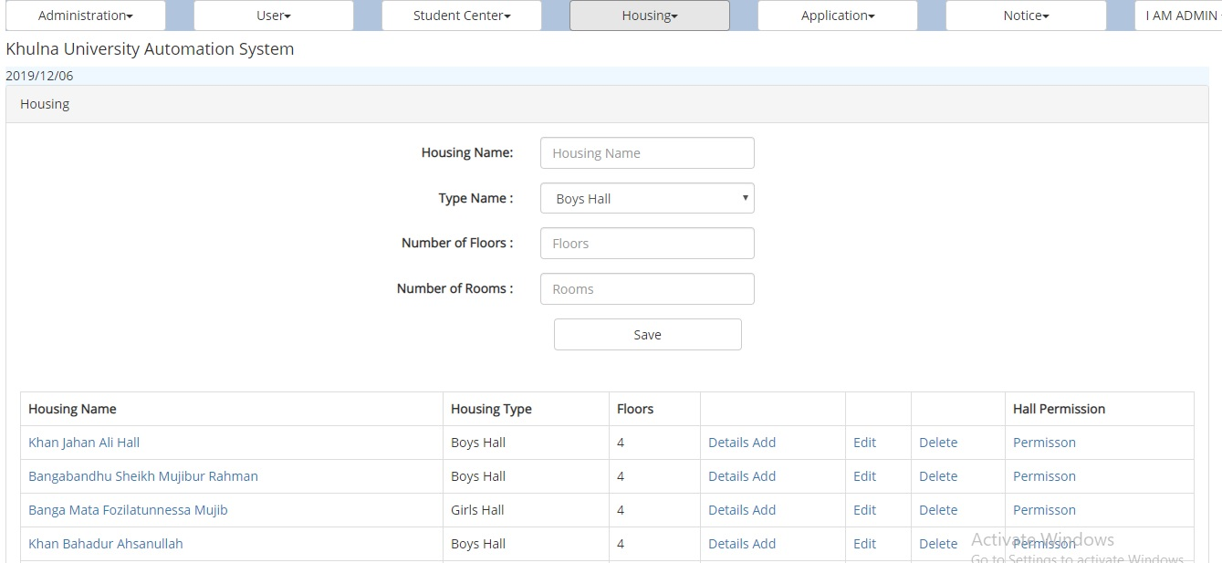

**Hall Permission:**

* This is the permission section of hall and housing management.
* Clicking the permission link of each hall the permission section of corresponding hall would appear which indicates the fact that only those users would be able to see and change the functionalities of respective hall.

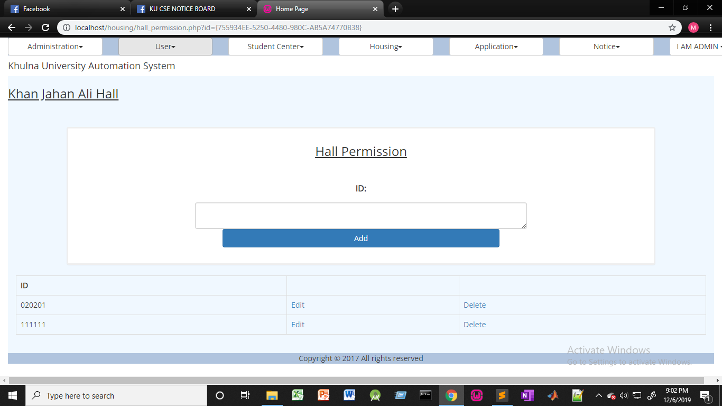

* In the above section users would be added by the admin to the specific halls.
* Each user added here would be able to see and manipulate functionalities like hall details, allotting seats , view applicants ,edit interview settings etc. of the respective hall.
* There are options for editing and deletion as well.

**Manage Housing Section**

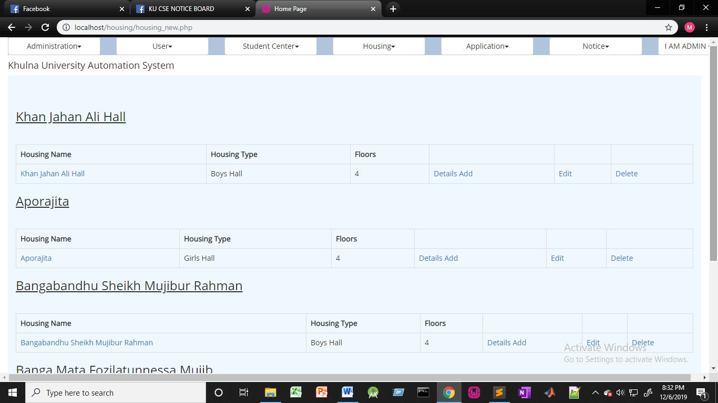

**Manage Housing:**

* Depending on the permission section, now the provost or other people who have been given access to the specific hall would be able to see the specific hall only. The upper pictorial view shows that the admin has access to all the halls.

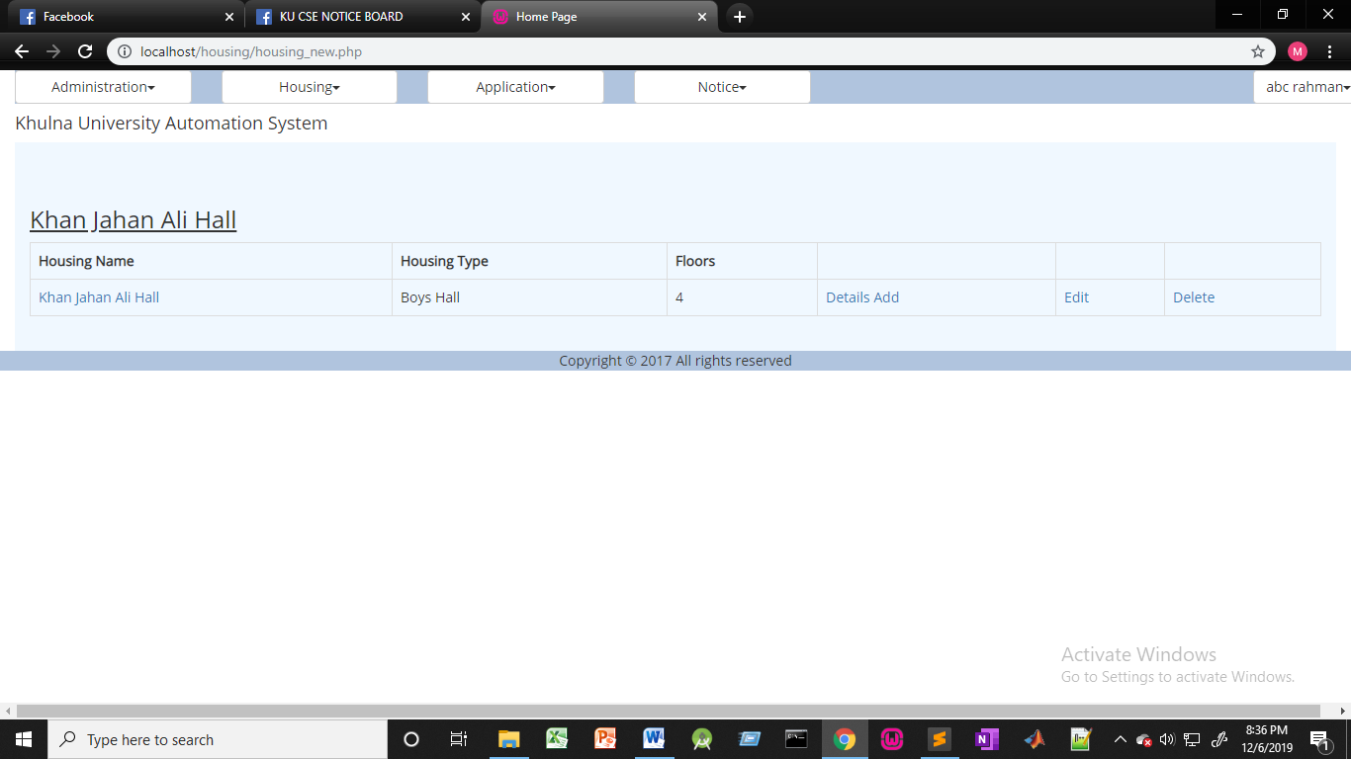

* But this pictorial view indicates that the user who has permission to the Khan Jahan Ali Hall would be able to manage the respective hall only.

**Issues Section**

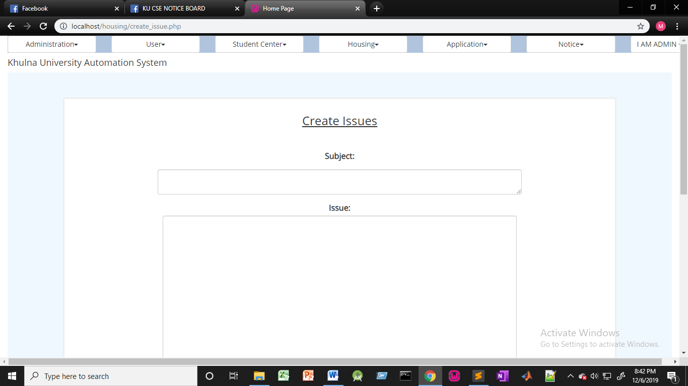

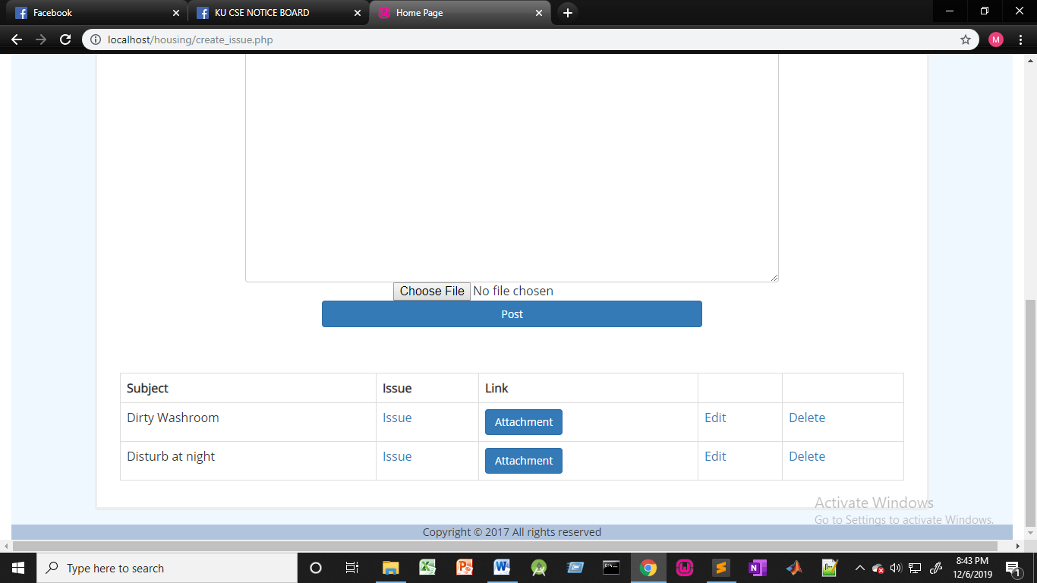

**Issues Section:**

* Here the users can create any kind of issues based on their respective subject.
* On important thing here is that the attachment section has been added here. So users can attach respective files as well.
* There are options for editing and deletion for the admin who can delete or edit them.
* The attachments can be edited and deleted as well.
* Only the admin or the people who have given access to can edit or delete the issues.
* Users can create the issues as well as view them.

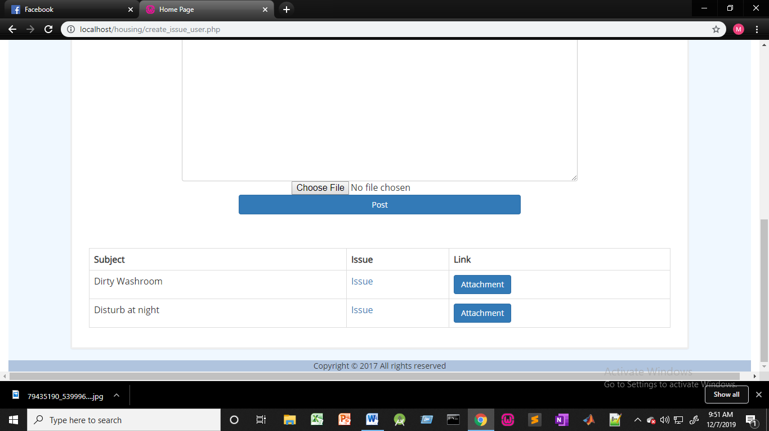

* This is the user version of issue creation where issues cannot be deleted ,only be viewed.

**History Section**

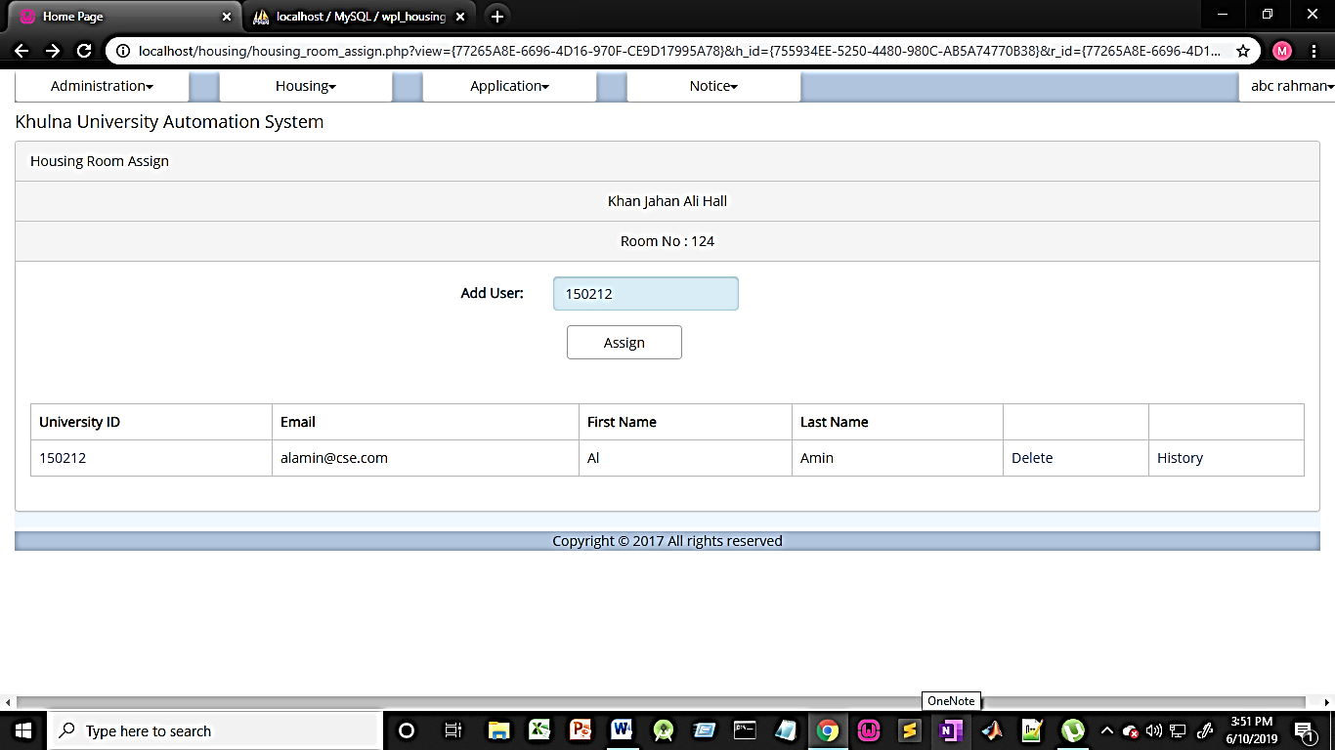

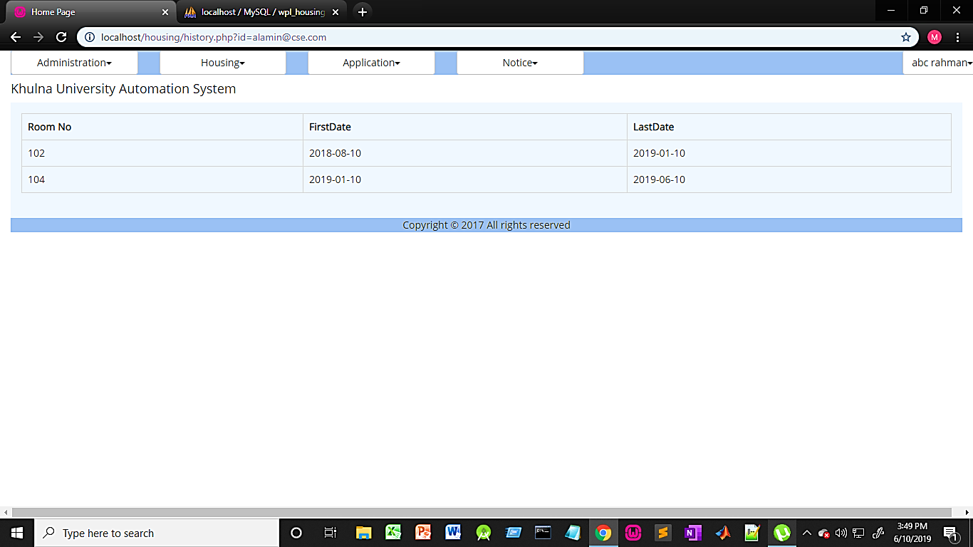

**History Section:**

* In this section clicking on the history link the admin or people who have been given access to respective hall would be able to see the history of a particular resident.
* The room number where the person was earlier can be seen.
* Again when the person was allotted to that particular seat and when the person left that seat can be also seen through First date and Last Date respectively.

**Apply For Seat Section**

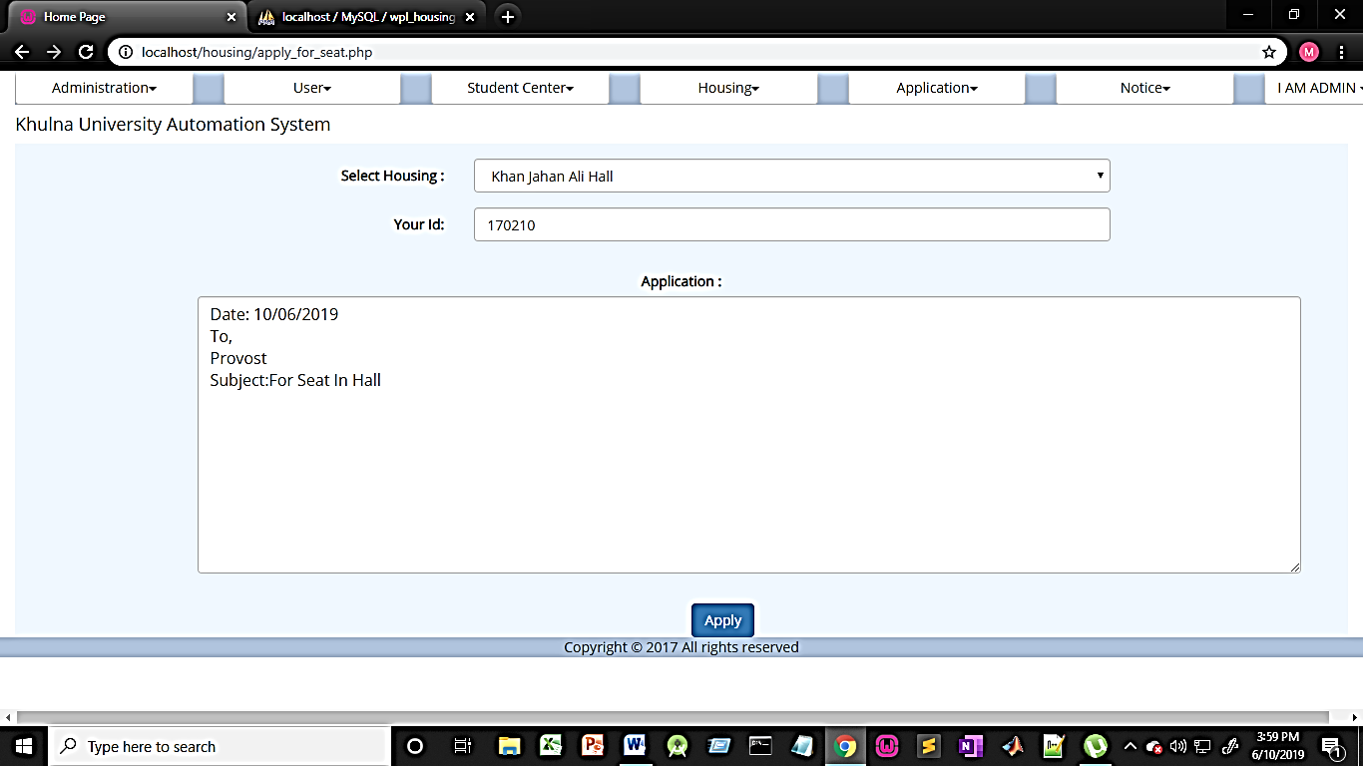

**Apply For Seat Section:**

* Clicking on the apply for seat students can apply for their respective halls.
* There is a drop down list where the students can select their respective halls and apply .

**View Applicants Section**

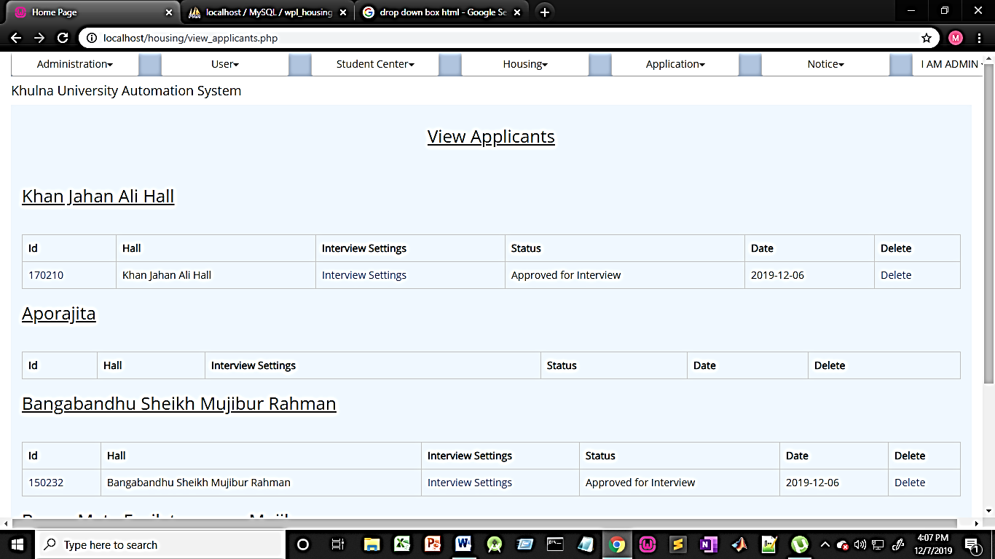

**View Applicants Section:**

* This section is basically for the admin and the hall officials.
* Only the people who are allowed the permission of a specific hall would be able to see the applicants of that specific hall.
* The upper pictorial view suggests that admin is allowed to see the applicants of all the halls.
* The image below would suggest the applicant view area of a person who is permitted to see the applicants of Khan Jahan Ali Hall.
* The permission process is stated already in the earlier hall permission section.

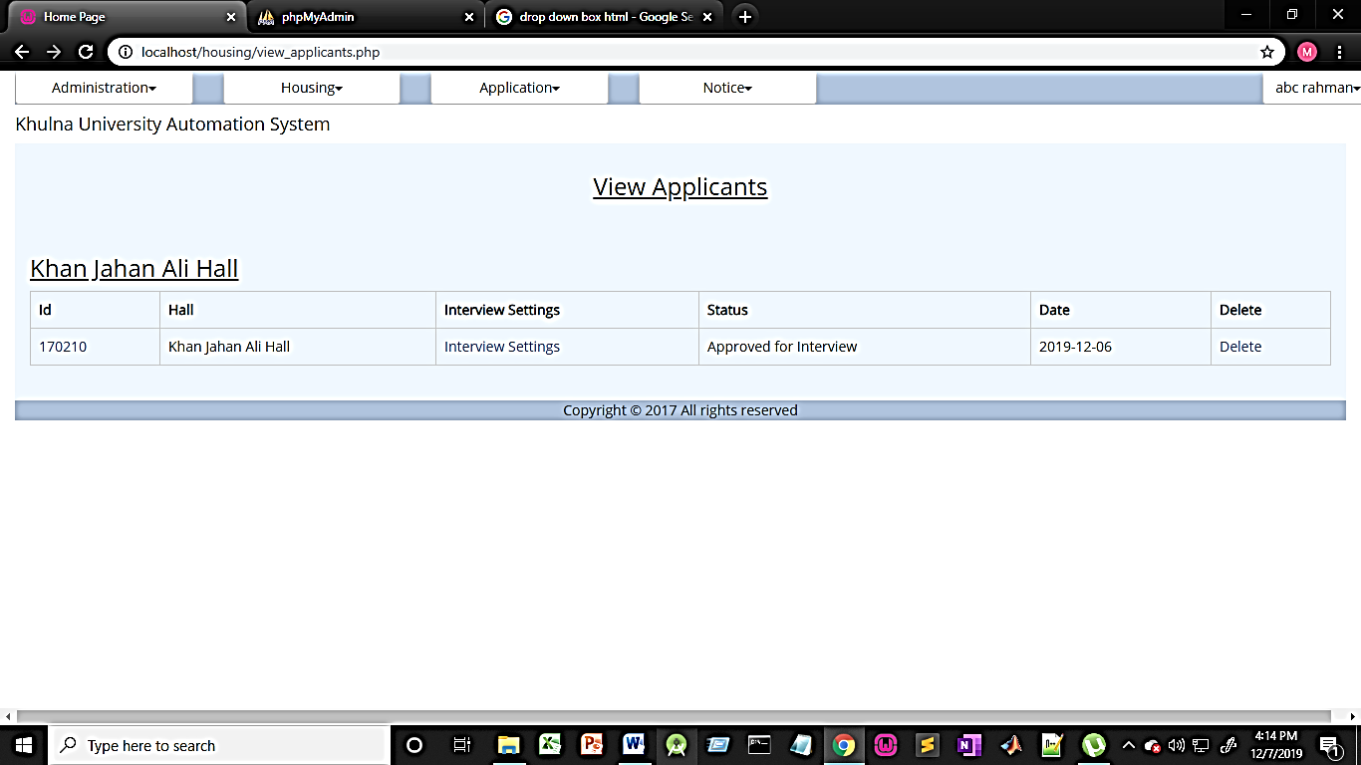

* By clicking on the id of an applicant , the details of an applicant can be seen.

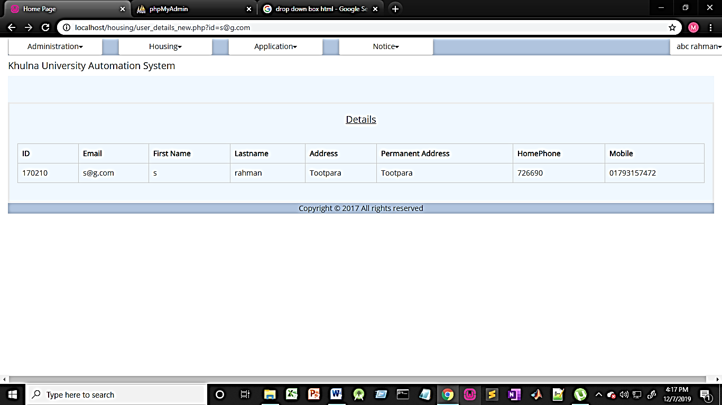

* In the view applicants section there is also the date is seen which indicates when the applicant has applied.
* There is also option for deletion.
* One more important column is the status which is basically the interview status that indicates that if the students has been called for interview or not.
* The status would be pending at the moment the student has applied.
* The status would only be changed by the hall officials by manipulating the interview settings section stated below.

**Interview Settings Section**

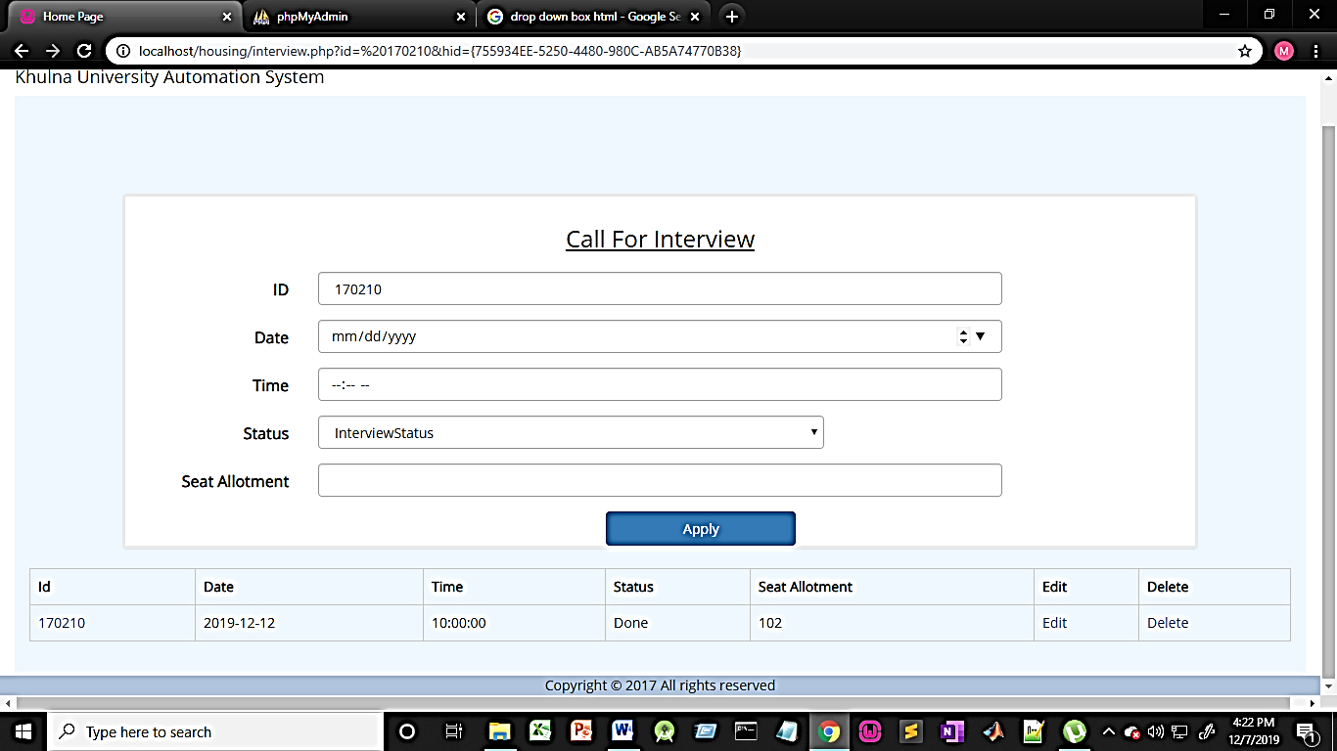

**Interview Settings Section:**

* Clicking on this section applicants can be called for interview.
* Date and time can be assigned by the hall officials.
* Here the status indicates that the applicants has attended the interview or not, which will be initially pending.
* After the interview the hall official can edit the interview settings and make the status as done.There is deletion option as well.
* There is also a column named seat allotment, which would be not allotted initially. After the interview happens, the lab official can assign the student to a room and as soon as the official assigns the seat allotment column will hold the room number that the student has been allotted else it would be NA.

**Interview List Section**

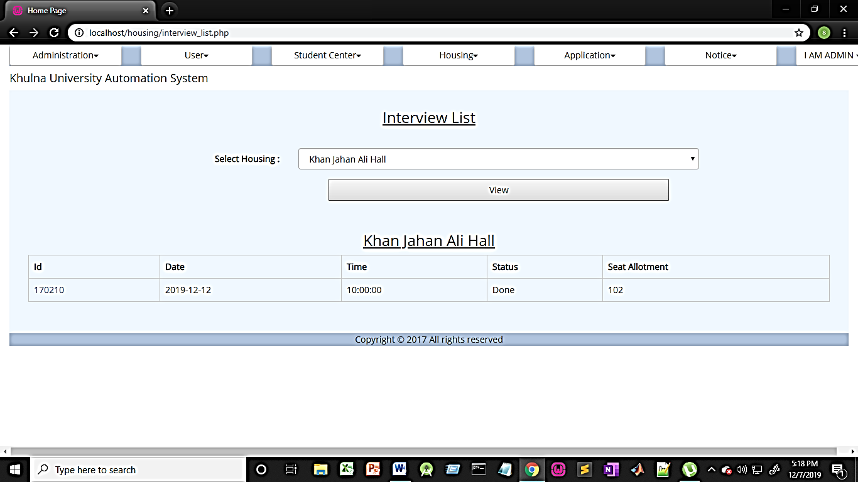

**Interview List Section:**

* This section is basically for all the users.
* Users can select their specific hall and see their interview status as well as interview result status.
* If they are in the interview list then they can see the time and date about when they have to go for the interview.
* After the interview they can check it again because it would be edited after interview and users can see their interview result status.

**Application Section**

A screenshot of a social media post

Description generated with very high confidence

**Application Home:**

* This is home of application.
* Clicking ‘Manage Application’ admin can see the applications
* Admin can create ‘Application Template’.
* User can choose application format.

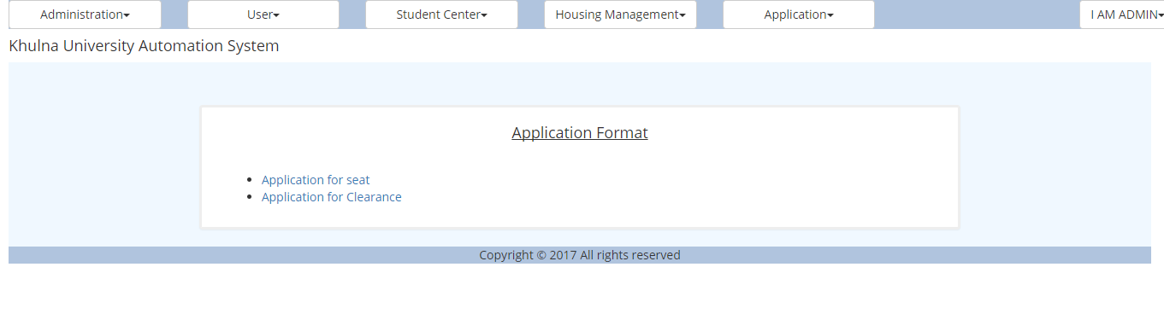

**Application Format:**

* User can select application format here.

A screenshot of a cell phone

Description generated with very high confidence

**Application Apply:**

* User can edit the given template from here.
* Apply to the department desired.

A screenshot of a cell phone

Description generated with very high confidence

**Application Manage:**

* Admin can see the submitted application here.